CO₂ Laser Assisted Canine Castration

William E. Schultz, D.V.M.
Schultz Veterinary Clinic
schultzvetclinic.com

This article describes a CO₂ laser-assisted canine castration procedure. The use of a CO₂ laser and an incision location not normally used for the surgery allow for a bloodless castration with reduced risk of scrotal hematoma, scrotal bruising or infection (in comparison with the conventional scalpel procedure described in Small Animal Surgery [1]) and results in a very small postoperative wound.

Anesthesia
The dog is premedicated with acepromazine/atropine/torbutrol with a preoperative chemistry panel being done while the preanesthetic is taking effect. Dogs less than 10 kg are masked with Sevoflurane and dogs larger than 10 kg are induced with Propofol 28 and then maintained on Sevoflurane for the procedure. When under anesthesia, an injection of morphine is given.

Preparation for surgery
The dog is placed in dorsal recumbency using a V-trough or chest positioner. The scrotum is shaved and a surgical prep with chloroxylenol is used to prepare the scrotum for surgery (Figure 1).

Surgical Laser
The high absorption rate of 10.6 µm wavelength of the CO₂ laser in water makes it the best practical laser for the soft tissue surgeries. The minimal collateral thermal effects of the CO₂ laser are sufficient for sealing blood vessels, lymphatics, and nerve endings. The high intensity of the laser beam destroys surface pathogens on incision/ablation margins, producing a sanitizing effect. The laser tip does not touch the tissue thus further lowering the risk of infection. Aesculight flexible fiber and its scalpel-like tipless handpiece (Figure 2) make the CO₂ laser a highly ergonomic and efficient tool for our everyday surgeries such as canine castration presented here.

Step 1: Initial Incision
The scrotum is draped and the Aesculight tipless laser handpiece H-FF with a .25mm diameter focal spot size is used with SuperPulse laser settings at 10 watts (Figure 2). The scrotum is held with light pressure on the testicle to stretch the tissues and an incision with 0.25mm size laser beam is made on the ventral midline of the scrotum (Figure 3). The incision is continued through the skin and not through the vaginal tunic (Figure 4). I prefer to do a closed technique but the vaginal tunic may be opened if an open castration is preferred.

Step 2: Removal of Testicles
The testicle is removed from the scrotum and the spermatic cord is gently cleaned of fat and connective tissue with a gauze sponge. The second testicle is pressed to the incision with a laser and the fascia is opened to the level of the vaginal tunic (Figure 5). The second testicle is also exteriorized, elevated and the spermatic cord is cleaned of fat and connective tissues (Figures 6 and 7).

Step 3: Cord Ligation and Wound closure
Small dogs will have the spermatic cords ligated with 3-0 Monocryl and larger dogs will be ligated with either 2-0 or 0-Monocryl (Figure 8). The cord is double clamped with mosquito hemostats and the cord is cut between the hemostats with scissors or laser (Figures 9-11). When the laser is used to transect the cords a saline sponge should be used as a backstop. The hemostat is removed from the cords and they are observed for hemorrhage (Figure 12) and then released. *If hemorrhage is noted in the scrotal incision defocus the laser beam by moving the hand away from the tissue and paint along the bleeding vessel to achieve hemostasis. The scrotal incision is then closed with a continuous subcuticular pattern using the remaining Monocryl (Figure 13). No skin sutures are used. Within minutes of the closure the scrotal tissues shrink resulting in an effectively smaller surgical incision (Figure 14).

Because the incision is made in the scrotum, and because the scrotum shrinks dramatically postoperatively, there are very few postoperative complications and licking is extremely rare.

Postoperative care
A canine NSAID is given for 4 days postoperatively and the dog is confined to leash only behavior for 5 to 7 days.

Conclusion
The surgical CO₂ laser allows for an almost completely bloodless surgical castration procedure with a rapid uneventful recovery. Flexible fiber CO₂ laser surgery can be easily learned by a skilled veterinary surgeon. Advances in beam delivery and handpiece technology make CO₂ laser surgery enjoyable as never before.
Reference
1. Hedlund CS. Surgery of the Reproductive and Genital Systems. In: Fossum TW (Ed). Small Animal Surgery, 3rd ed, St. Luis, MO: Elsevier/Mosby, 2007; 702–774.

Bio
Dr. Will Schultz graduated from Michigan State University in 1973, went into private practice and opened his companion animal practice in the fall of 1974. Dr. Schultz has been a board member on the Synbiotics Reproductive Advisory Panel, The Society for Theriogenology and The Theriogenology Foundation with speaking engagements at several veterinary conferences, veterinary associations and national specialties because of a special interest in canine reproduction. Dr. Schultz has lectured and published articles on transcervical and surgical inseminations using fresh, chilled and frozen semen. Soft tissue and orthopedic surgery are also areas of special interest with laser surgery being an important modality for over 20 years. Currently Dr. Schultz is using a 20 watt flexible waveguide CO₂ laser with constant and SuperPulse modes.

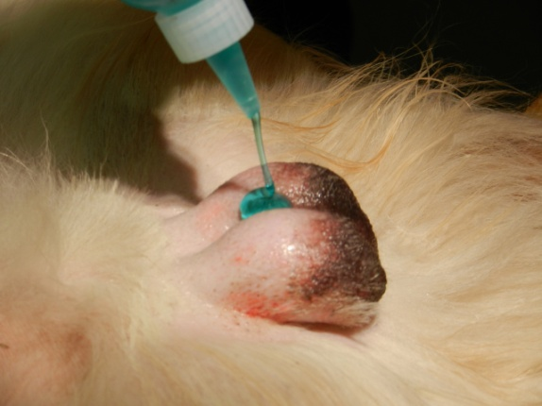  Figure 1 | 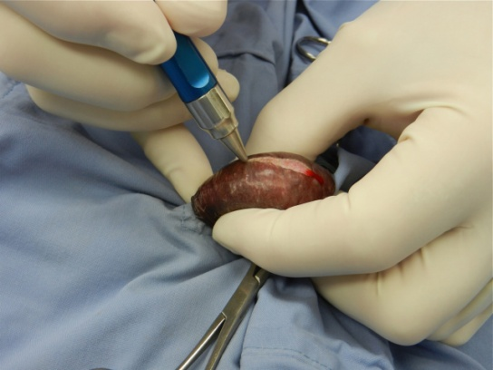  Figure 2
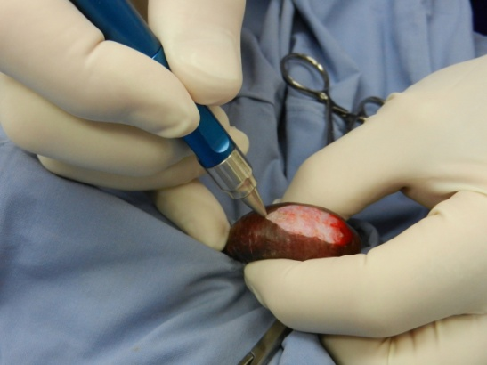  Figure 3 | 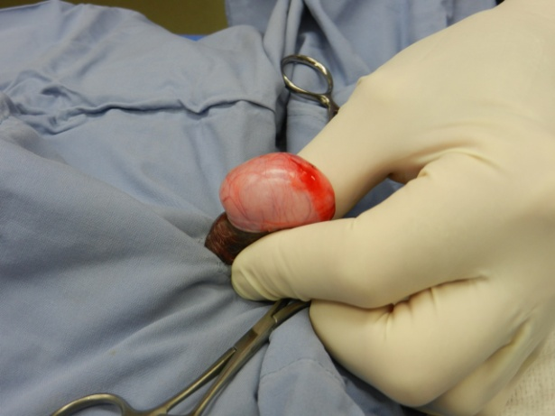  Figure 4
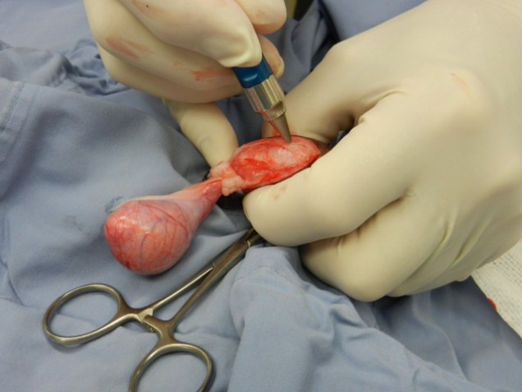  Figure 5 | 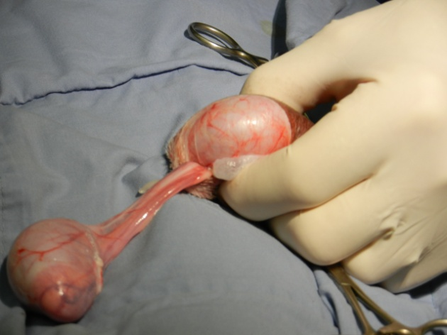  Figure 6
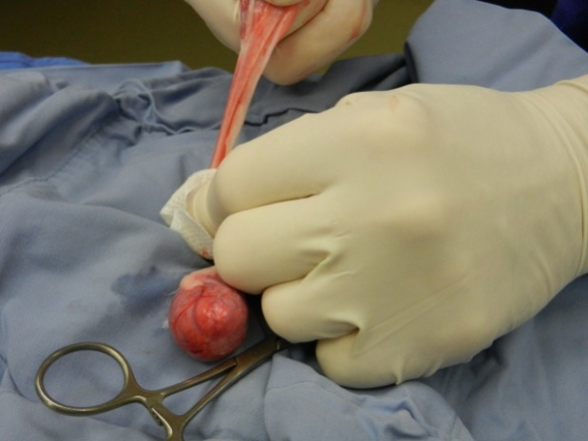  Figure 7 | 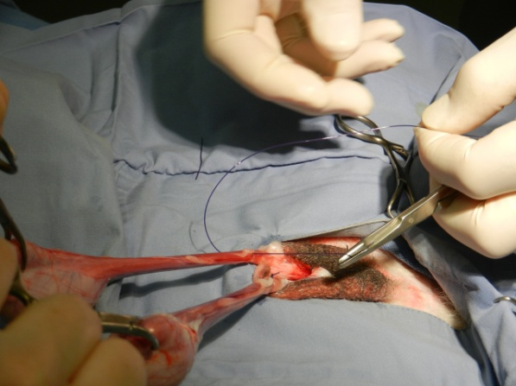  Figure 8
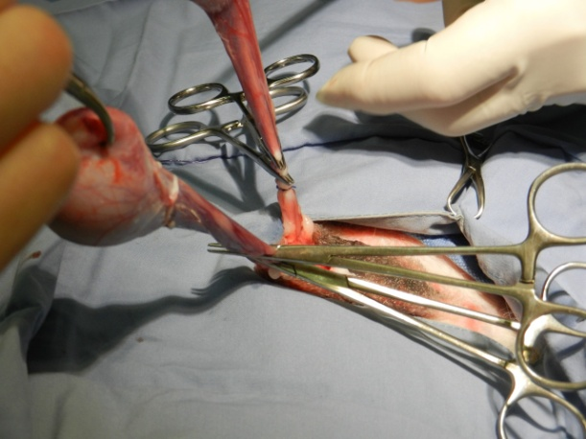  Figure 9 | 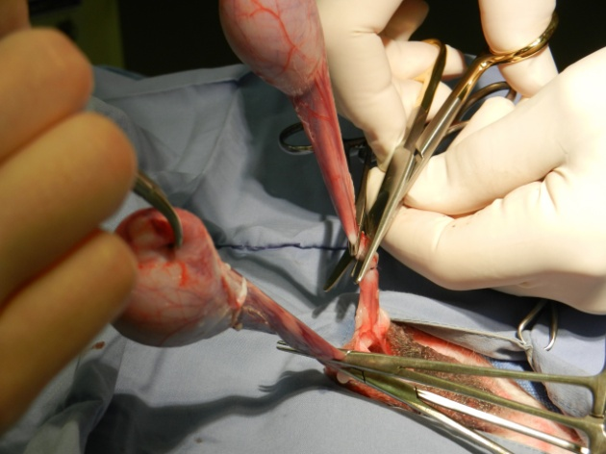  Figure 10
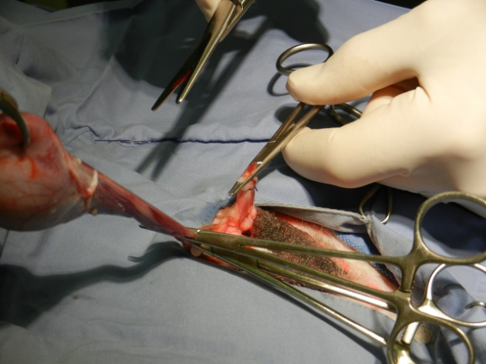  Figure 11 | 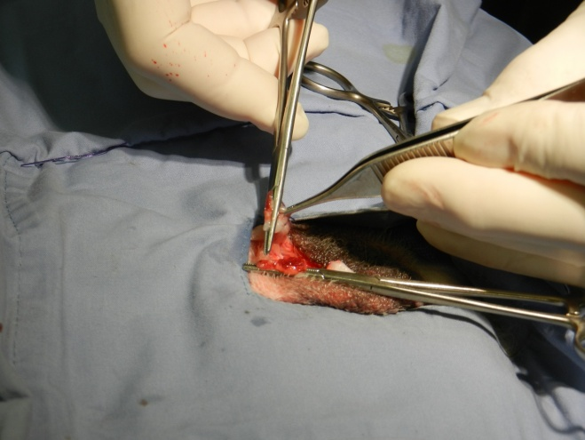  Figure 12
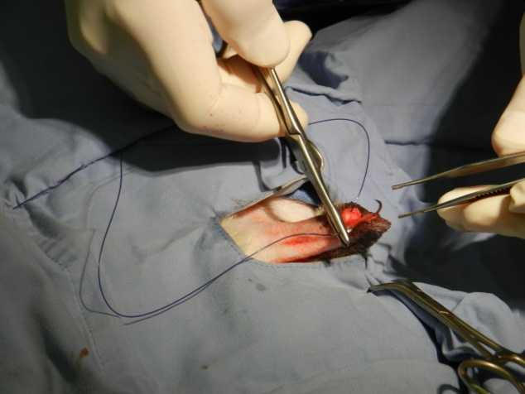  Figure 13 | 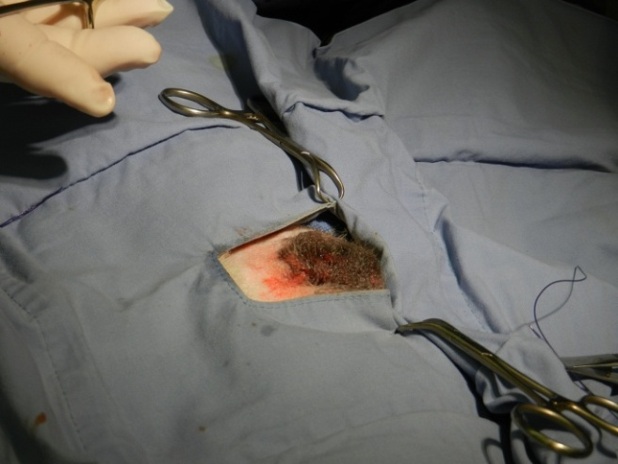  Figure 14

