Laser Removal of Anal Glands
By William E. Schultz, D.V.M.

Introduction: Laser Assisted Surgery
Laser surgery has dramatically changed the visual surgical field by controlling hemorrhage without the tissue damage associated with electrosurgery and the enhanced visual field afforded the surgeon. Delicate dissection with visualization is a hallmark of laser surgery. Anal gland removal is one surgery where the use of a laser dramatically decreases the bleeding and facilitates a rapid removal of the anal glands. In the case below a flexible fiber waveguide CO₂ laser was used with the Aesculight adjustable tipless handpiece.

Anesthesia
We pre-medicate the patient with a mixture of torbutrol, atropine and Acepromazine. Induction is with Propofol 28 if over 25 pounds and if under 25 pounds we will mask with Sevoflurane. Maintenance is with Sevoflurane. Either morphine or buprenorphine is used for pain control during the procedure. NSAID therapy is used postoperatively for 4 days. These dogs have very little discomfort postoperatively with this protocol.

Procedure Preparation
The dog is placed in a sternal recumbency with the tail elevated and the rear legs off the table. The use of a small beanbag or rolled towels to elevate the pelvis is helpful. The anal glands are then emptied as completely as possible. The anal glands are filled with dental impression material (Alginate) and the material is allowed to harden. This material is flexible and is not hot when it hardens lessening the chance of ancillary tissue damage outside of the anal glands. Alginate is a powder that is mixed with cold water and loaded in a catheter tipped syringe or a syringe with a shortened tomcat catheter attached. The working time is 2 to 3 minutes after mixed. The glands are filled until material is leaking out around the catheter (Figure 1). Also, during surgery I wear a headlight and it is aimed away from the surgical field for the pictures, as the bright light may cause the camera to overexpose the surgical site. The material does not heat when it turns solid and effectively fills the gland for ease in dissection. Visualization of the anal gland ducts before the Alginate is mixed is a good idea.

Initial Incisions
Skin incisions are made from about 3:00 to 5:00 on the right side and 9:00 to 7:00 on the left side of the perineum at the junction of the haired and non-haired tissues. The laser is set at 8 to 10 watts SuperPulse and 0.25 diameter spot size is used for these incisions.

Blunt Dissection
After the skin is incised, blunt dissection is done to separate the external anal sphincter muscles (Figure 2). Usually, with the incisions in the described location the muscle is very thin and may be medial to the incision. The anal gland is visualized and blunt dissection is done to separate the gland from the surrounding tissues (Figures 3 and 4). In cases where the anal glands had previously ruptured or had severe infection the dissection may be difficult. When scar tissue is thick the laser may be turned to 3 to 4 watts SuperPulse for dissection, again with 0.25 diameter spot size. Gentle retraction of the fascia will allow the laser to dissect easily without damage to the anal gland.

During the blunt dissection the caudal and lateral aspects are usually easily done (Figures 5 and 6) but the cranial aspect is more difficult to reach. These areas are easily dissected using gentle caudal traction on the anal gland and the laser to separate the tissues (Figures 7and 8). The duct is isolated and ligated close to the colon with 3-0 or 2-0 Monocryl depending on the size of the dog (Figure 9). The laser is used to cut the duct and remove the gland (Figures 10 and 11).

It is very important in closure of the incisions that the sciatic nerve be spared. If the anal glands are very deep, the nerve may be visible, but in most cases the nerve is deep to the cranial aspect of the surgical field. Either 2-0 or 3-0 Monocryl is used in a loose vertical mattress pattern to close the wound (Figure 12). Two to three sutures are placed and glue is used in the skin (Figure 13). Figure 14 demonstrates the removed anal sacs.

Post-Operative Instructions
If needed, an E-collar is used post op and in some cases diapers (Pull-Ups) may be used. With the laser most dogs do not scoot or lick at the incision. We counsel owners to keep the dog on a leash for one week post-op and watch for any swelling or drainage. In the rare case the incision opens, it is treated as an open wound and allowed to granulate instead of placing new sutures. Granulex is an excellent product to increase the rate of second intention healing.

Summary
Note the lack of bleeding during the procedure. The ability to visualize the surgical field without hemorrhage and the enhanced dissection afforded by using a surgical laser speeds up the procedure and causes much less trauma to sensitive perineal tissues.

Bio
Dr. Will Schultz graduated from Michigan State University in 1973, went into private practice and opened his companion animal practice in the fall of 1974. Dr. Schultz has been a board member on the Synbiotics Reproductive Advisory Panel, The Society for Theriogenology and The Theriogenology Foundation with speaking engagements at several veterinary conferences, veterinary associations and national specialties because of a special interest in canine reproduction. Dr. Schultz has lectured and published articles on transcervical and surgical inseminations using fresh, chilled and frozen semen. Soft tissue and orthopedic surgery are also areas of special interest with laser surgery being an important modality for over 20 years. Currently Dr. Schultz is using a 20 watt flexible waveguide CO₂ laser with constant and SuperPulse modes.

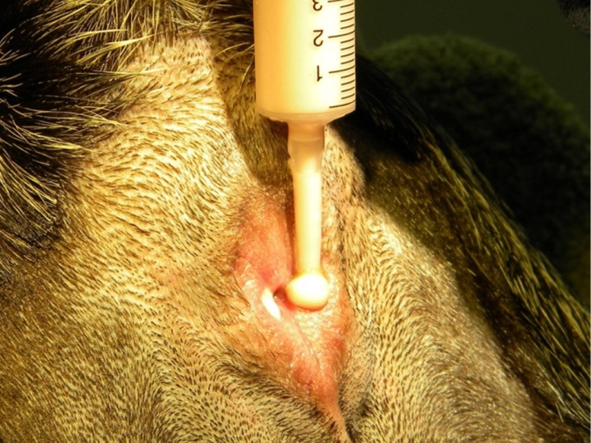  Figure 1 | 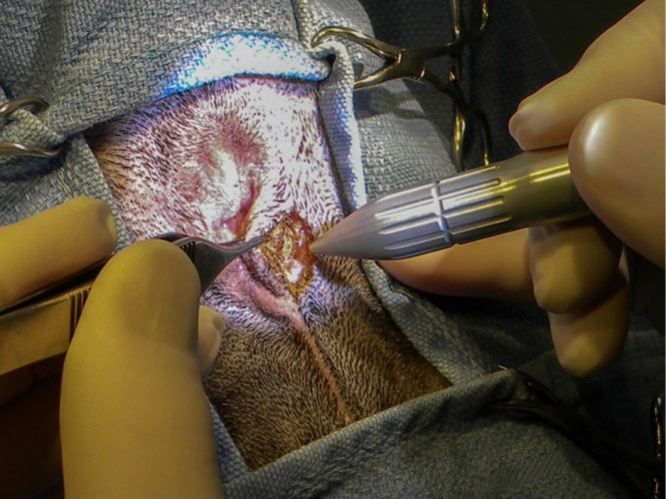  Figure 2
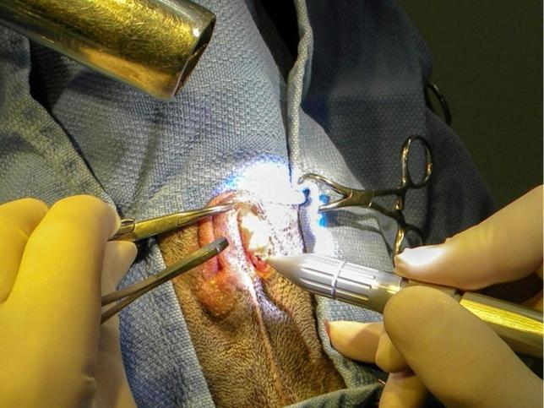  Figure 3 | 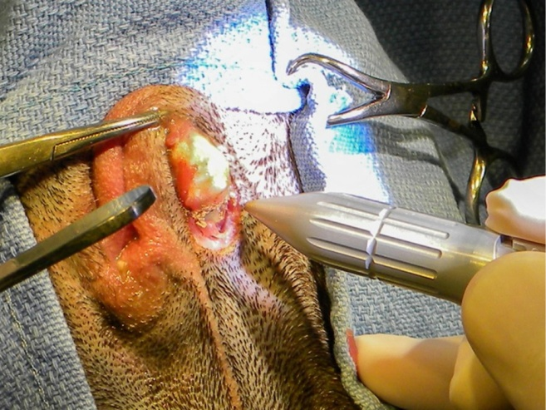  Figure 4
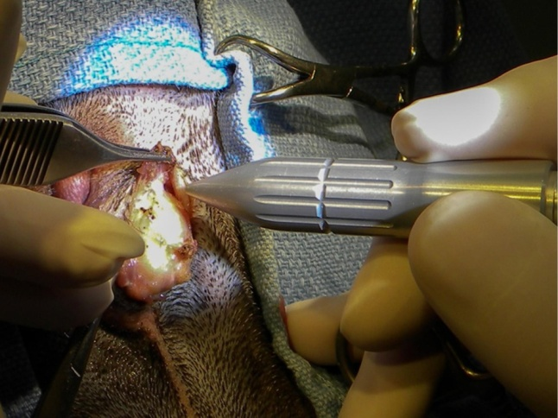  Figure 5 | 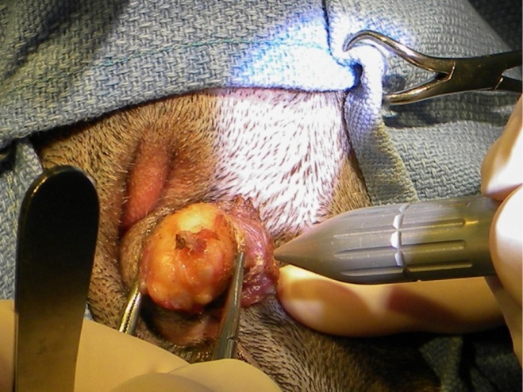  Figure 6
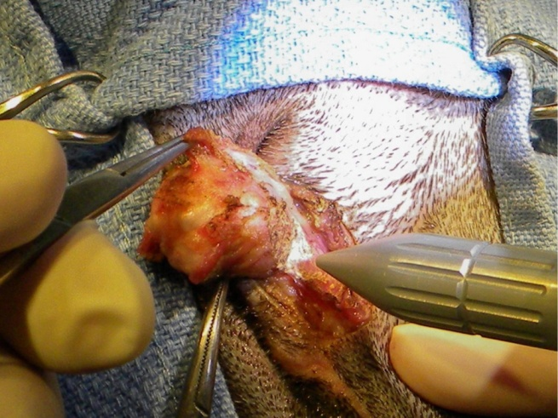  Figure 7 | 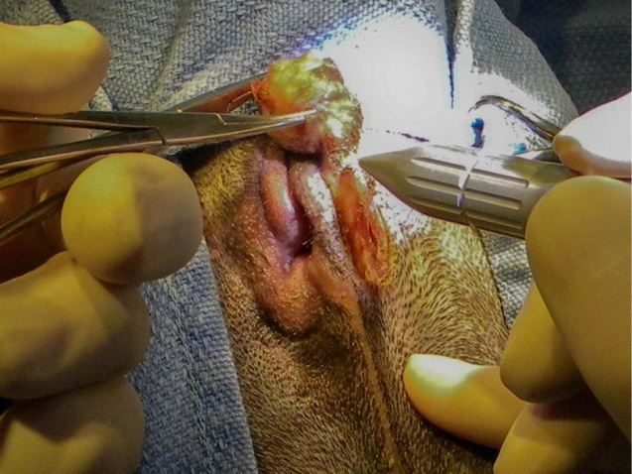  Figure 8
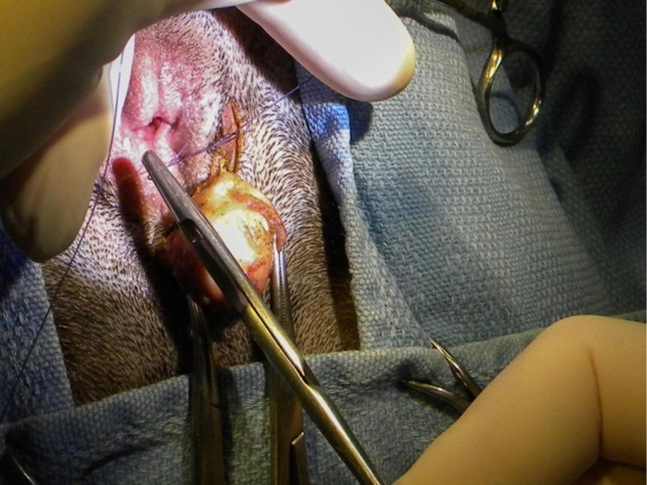  Figure 9 | 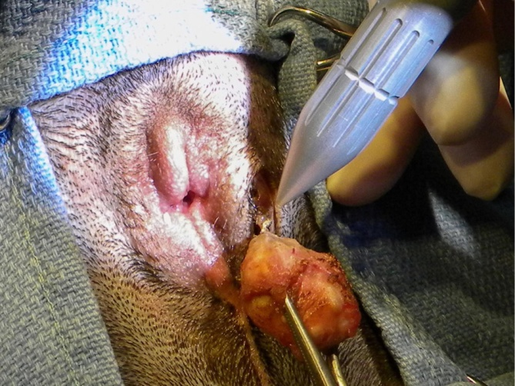  Figure 10
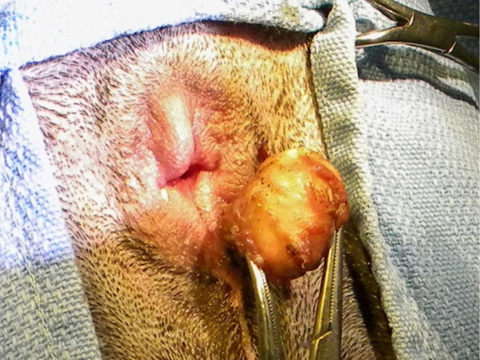  Figure 11 | 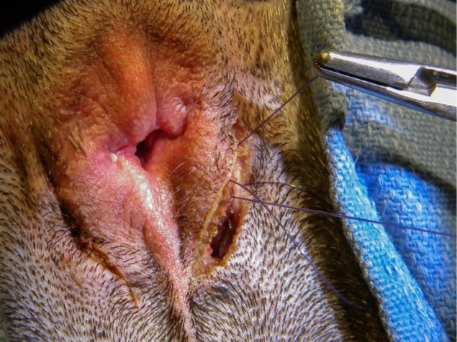  Figure 12
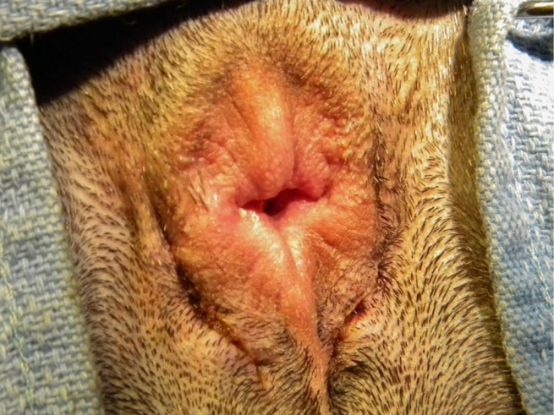  Figure 13 | 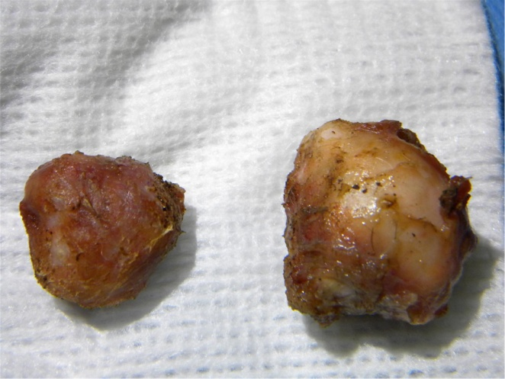  Figure 14

